# **EXPLORATORY ANALYSIS OF CITRUS FARMING**

# **AMIDST THE “GREENING” PROBLEM IN POLK COUNTY, FLORIDA**

By

Miguel Cecchini do Amaral

Mentors:

Dr. Reinaldo Sanchez-Arias

Dr. Melba Horton

Florida Polytechnic University

# **INTRODUCTION**

Florida’s signature citrus industry has a tremendous value for the state’s economy and contributes substantially to employment opportunities. Florida has a crucial role of total United States citrus fruit production and was considered the country's largest orange and grapefruit producer in 2015 (FDACS, 2015) and the third-largest citrus fruit producer in the world (Putman, 2017). However, the industry has been threatened by biotic and abiotic factors, leading to an immense economic loss (Neupane *et al*., 2016). The endemic presence of Huanglonbing (HLB), or citrus “greening disease”, is considered the most devastating factor for the decrease in production and is the biggest responsible agent for the worst orange harvest crisis in the state in a century (Neate, 2016). Since the establishment of the disease-causing bacteria in Florida in 2005, the citrus fruit production had a 65% drop compared to the 2016/2017 harvest (Putman, 2018*)* and a colossal economic, social, and environmental impact. This citrus “greening” problem is not a local phenomenon but has spread in more than 40 countries around the world (Bové, 2006*)*. A lot of effort has been invested in trying to understand the nature of the disease, however, the current knowledge and understanding of the ecology of the problem does not provide efficient management measures for the farmers and other stakeholders (Neupane *et al*., 2016). Meanwhile, business is on the losing side and most importantly the socio-economic conditions of every area that has been hit by the disease is deteriorating (Neupane *et al*., 2016) hence the purpose of this research work.

# Considering the complexity of the citrus business industry, it is therefore crucial to understand the baseline problems occurring in small sectors especially the growers/farmers who are the most directly hit and work the way up to have a better grasp of the root of the issue in order to find a better alternative. The bulk of the information that will be used to support the claims throughout this conceptual paper will be derived from reports, maps and stats provided by the USDA (United State Department of Agriculture) and NASS (National Agriculture and Statistic Service).

# The guiding axis of this research is to explore existing data on the business status of farmers/growers of the citrus industry specifically within the Polk County area as affected by the “greening” disease. One of the main objectives is to gain insights of the core issue and ultimately provide a conceptual framework of the possible actions/programs to be undertaken to improve the status quo. It is hypothesized that proper implementation of the proposed plan of action improves the business condition of the growers/farmers of the citrus industry albeit inevitable problems such as citrus greening and the like.

**PURPOSE/NEED/RATIONALE**

Florida’s citrus fruit industry has been part of the state’s identity for centuries. Around the 1800s, the ideal climate and soil conditions, along with the development of railroads, enabled Florida to become the perfect scenario for the commercial production of citrus fruits (FDOC, n.d). The potential industry attracted many farmers/growers to the state, causing a tremendous boost in its popularity and the spread of groves all over the state. Over time, citrus trees became an iconic symbol of Florida’s landscape and a crucial element in Florida’s economy.

In order to understand the real economic impact of Florida’s citrus industry, it is important to make a comparison of citrus production in different scales. Taking into consideration that the United States was for decades ranked the second largest orange and grapefruit producer in the world, and Florida is historically the state that produces such citrus fruits the most in the country, Florida’s contribution to the citrus industry is therefore of worldwide significance (Putman, 2017). Nationally, the 2003-2004 citrus fruit production in Florida accounted for ~ 80% of the United States’ total citrus production (Bronson, 2005) and it was estimated an output impact of more than nine billion dollars, providing employment opportunities for over seventy-six thousand direct and indirect workers (Hodges et al., 2006).

Although most of the groves were concentrated historically in Florida’s south peninsula, wherein the probability for freeze occurrence during winter seasons is lower, Polk county, located in the central region, is the state’s biggest citrus producer (FDOC, n.d). This makes Polk county the heart of the nation’s citrus production. Traditionally, citriculture has always been one of the key factors in the county's economy. The impact of the contributions of this industry (fruit production, packinghouses, and processing / juice manufacturing) in Polk County was estimated in 20012/13 at $3.06 billion in output, $1.43 billion in value added contribution to GDP, and 15,768 full or part-time jobs (Hodges and Stevens, 2015).

# In August 2005, a disease-causing bacterium was identified for the first time in Florida, causing the most devastating disease among all citrus trees: the citrus greening disease (Bové, 2006). Also called Huanglongbing (HLB), the widely spread disease in Florida, which can be transmitted via psyllid vectors, grafting, dodder, and seed, has caused, within the past 14 years, incalculable damage. The trees affected by this disease, besides having an extremely short life expectancy, produce small, bitter fruits that fall prematurely and cannot be sold or used as juice (Halbert. and Manjunath, 2018). The disease reaches the tree’s vascular system and, once the tree is affected, there is no cure (Hickey, 2017).

# The disease was first reported in the southern part of China in 1919, and now there are evidences of its presence in 40 countries throughout Asia, Africa, Oceania, South and North America (Bové, 2006). So far, there are no curative methods of HLB, and there is no place in the world where citrus greening disease occurs that has efficient management measures, making the centenary disease a destructive element in the citrus industry all over the world (Haelbert and Manjunath, 2018). Since HLB bacterium was not obtained in culture, there is no knowledge of many parameters necessary to develop a possible cure, despite over 90 years of research (Gottwald and McCollum 2017). In Florida, the disease is caused by the bacterium *Candidatus* Liberibacter asiaticus and is transmitted by the natural vector *Diaphorina citri* (Bové, 2006), a type of insect commonly known as Asian citrus psyllid. Researchers recommend the conduct of more *in-situ* ecological studies to better understand the occurrence and spread of HLB in order to find more efficient preventative measures (Mann et al., 2018; Martin et al., 2018)

The economic and social impact of the greening disease on citrus production, the industry’s output contribution, and employment opportunities, are devastating coupled with the exposure of the ineffectiveness of existing disease control measures available. Although there are not enough researches estimating the real total consequences of the greening disease, the current available data related to this topic show that the magnitude of the losses tends to rise even more in the next years (Neupane *et al*., 2016). In a research conducted by the Florida Department of Agriculture Economic & Market Research, if no remedy for HLB will be found in the next 10 years, the perspective of the future of citrus industry in Florida is highly pessimistic, reaching by 2025/26 a drop of ~ 90% in orange and grapefruit production compared to the harvest of 2003/2004 (Spreen and Zansler, 2015).

When it comes specifically to the loss of production, the data are alarming. In this article, in order to compare the true production loss in citrus fruits, the United States Department of Agriculture (USDA) official data were used to relate the statistics of the last published harvest, 2016/2017, to the 2003/2004 harvest, in which the bacterial infestation had not yet been observed in the state of Florida. In 2003/2004, the state’s total citrus production was 291.8 million boxes of which 42.2 million came from Polk county (USDA, 2004), contrasting with only 78 million boxes whereby 11.6 million came from Polk county in 2016/2017 (Putman, 2018). Such data display a decrease of ~74% in citrus production in 13 years and the lowest harvest since 1944/45.

There is not a proportionately direct relation between the output contribution of the industry and the colossal drop in citrus production. In 2003/04, the year of the second largest citrus crop in Florida's history, it was estimated a citrus industry output contribution of 9 billion dollars, including the contributions of citrus fruit production, citrus fruit manufacturing and fresh citrus marketing (Hodges, et al, 2006). In contrast, in the years 2012/13 and 2015/16, the citrus industry had an economic contribution of 12 billion and 8 billion dollars respectively (Court, e.at., 2017). These data indicate that the total applicable economic contributions of the industry have different factors that interfere in its alteration, such as the increase in the product price on the market. Thus, to obtain the evaluation of the real economic loss due to greening disease, it would be necessary to hypothesize a scenario without the presence of HLB and take into consideration all the different factors that could interfere in the final result. Nonetheless, there are no current studies available on the total economic impact of the greening disease.

The social impact caused by the greening disease affected greatly the job market in the citrus industry. In 2015/16 only 45,422 jobs were created for both full-time and part-time (Court et al., 2017) compared to 2003/2004’s 76,336 jobs, accounting a 40% decrease in employment contribution (Hodges et al., 2006). Moreover, between 2012 and 2015 years, the intensification of the HLB establishment has caused thousands of unemployment, being the main responsible for the closure of around 7,945 jobs per year (Court, et al., 2017).

Considering the degree of devastation that the greening disease is costing the whole citrus industry, it is therefore vital that an analysis of the data, the technologies available to help the existing problem, and the processes used by organizations who are directly and/or indirectly involved in the business planning in Polk County needs to be put in place, hence the conduct of this proposed research work.

**PROJECT DESCRIPTION**

**Objective**

This study aims to better understand the current situation of the citrus farming industry in Polk County amidst the challenges brought about by the “greening” problem. Consequently, a conceptual framework of the possible actions/programs that need to be put in place that can serve as a guiding template for various sectors and stakeholders in finding a better solution to the existing problem will be provided.

**Methodology/Action Plan**

In order to carry out a substantial analysis, the methodology was based on the gathering of credible data derived from scientific literature and governmental websites and documents. The main sources of information used to support the scientific analysis were the United States Department of Agriculture (USDA), NASS (National Agriculture and Statistic Service) and UF / IFAS (Institute of Food and Agriculture Science). Also, an email interview was conducted with the CHMA (Citrus Health Management Areas) extension agent in Polk county, Chris Oswalt. As part of the explanatory data analysis, records were collected using data available at NASS - Florida Citrus Statistics from 2003/04 to 2016/17 and visualizations were created using the R statistical programming language.

Observing the pessimistic trend of the future of the Florida citrus industry and analyzing the results of current disease management measures, the process to solve the greening problem is far from over. For the continuation and expansion of the work, the article foresees the possible implementation of an adequate plan of action in the Florida citrus industry, short and long-term solutions, especially in Polk county, along with a seasonal analysis of the progress and results of the new control measures executed.

**Preliminary Outcomes**

**Table 1.**  Local Institutions Related to Citrus Industries in Florida

|  |  |  |
| --- | --- | --- |
| NAME | FUNCTION | ROLE IN THE HLB PROBLEM |
| (CREC) Citrus Research and Education Center -UF | For the past 100 years, the University of Florida (UF) Citrus Research and Education Center (CREC) has been honored to assist the citrus industry in meeting its developmental needs through its Research, Extension, and Teaching programs. CREC is the oldest and largest off-campus experiment station in UF's Institute of Food and Agricultural Sciences (UF/IFAS) and is unique among research centers in that it focuses entirely on one commodity, citrus. CREC discovers and delivers innovative solutions that empower citrus and other agricultural interests to conduct responsible and profitable business. | Research |
| (CHMA) UF Citrus Health Management Areas – UF | Its goal is to slow the spread of citrus greening disease and preserve the current Florida commercial citrus acreage. The purpose of CHMAs is to encourage neighboring citrus growers to work together to combat citrus greening, particularly through the coordination of psyllid control efforts. The goal of the CHMA is to coordinate the timing and ensure the proper rotation of pesticide mode of action to obtain the best psyllid control possible while minimizing the potential for pesticide resistance development. Growers can use any application method they desire (aerial, low-volume, speed sprayer) so long as these goals are achieved. | Collaboration of several groups of participants including citrus growers/regional grower organization, UF-IFAS and FDACS-DPI. For each CHMA there is a specialist leader who organizes the local planning meetings and helps maintaining the communication between different CHMA. FDACS conduct routine psyllid scouting on each CHMA to provide real-time information on psyllids population in each region. The data helps making pest management decisions |
| The Horticultural Science Department – UF | The Horticultural Sciences Department at the University of Florida dedicated to improving fruit and vegetable production for the benefit of farmers and consumers.  They conduct cutting-edge research in plant breeding & genetics, plant and environmental physiology, fruit & vegetable production, postharvest physiology, biochemistry, and other disciplines. | Research |
| (CRDF) Citrus Research and Development Foundation -UF | The Citrus Research and Development Foundation is a non-profit corporation organized under Florida State laws as a Direct Support Organization of the University of Florida. The Mission of the Foundation is to “Advance disease and production research and product development activities to ensure the survival and competitiveness of Florida’s citrus growers through innovation”. | Research |
| The Citrus Administrative Committee | Federal Marketing Order, administered by the USDA, and sets minimum sizes and grades of fresh Florida Citrus. | No data |
| (FLARES) The Florida Research Center for Agricultural Sustainability, Inc. | Innovative, science-based strategies and solutions to provide profitable sustainable agriculture. | Research |
| The International Society of Citriculture. | It’s a non-profit organization in which the objective is to strengthen internationally the development of science and technology for the benefit of the worldwide citrus industry. Around 24 countries. | It has a periodical called ‘’The Journal of Citrus Pathology’’ which welcomes reports on research from branches of pathology on all diseases of citrus related fields. |
| (FCPRAC) Florida Citrus Production Research Advisory Council. | FCPRAC operates under the Florida Citrus Production Research Marketing Order, which allows growers to tax themselves up to 1 cent per box of fruit and direct those funds to help solve citrus production problems. | No data |
| Florida Citrus BMP Programs | Agricultural Best Management Practices (BMPs) are practical measures that producers can take to reduce the amount of fertilizers, pesticides, animal waste, and other pollutants entering our water resources. They are designed to improve water quality while maintaining agricultural production. FDASC has a Citrus BMP Manual and UF has a website | No data |
| The Florida Citrus Archives | We collect all materials related to the citrus industry from marketing materials like citrus crate labels, to the photographs and papers of groves and individuals involved in the industry. We preserve these materials and make them available to researchers and the public. | No data |

**Table 2.** State Institutions Related to Citrus Industries in Florida

|  |  |  |
| --- | --- | --- |
| NAME | FUNCTION | ROLE IN THE HLB PROBLEM |
| (FDOC) Florida Department  of Citrus | State agency in charge of regulating and marketing the state's [citrus industry](https://en.wikipedia.org/wiki/Citrus_industry) and citrus research, paid by growers. | No data |
| (FDACS) Florida Department of Agriculture and Consumer Services. | * It promotes Florida agriculture, protects the environment, safeguards consumers, and ensures the safety and wholesomeness of food. Their programs and activities are varied and include the assistance to businesses and residents in the safe and proper use of pesticides. | Research funding |

**Table 3.** National Institutions Related to Citrus Industries in Florida

|  |  |  |
| --- | --- | --- |
| NAME | FUNCTION | ROLE IN THE HLB PROBLEM |
| (NASS) National Agriculture and Statistics Service - USDA | Main agricultural data gathering agency in Florida with the purpose of collecting, compiling and providing current statistics. | No data |
| U.S. Citrus and Subtropical Products Research Laboratory -USDA | 1. Determine the critical factors that limit standard and novel citrus cultivars’ ability to thrive and become productive in Florida, where HLB and its vector are endemic. 1a. Determine the effects of HLB on response to abiotic and biotic stresses. 1b. Determine the HLB susceptibility of various rootstock/scion combinations in green house trials. 2. Protect and/or rescue valuable and unique ARS citrus germplasm from infection by HLB through appropriate methods, including, micrografting, cyrotherapy, thermotherapy and antibiotics as necessary. 2a: Rescue high-value, novel germplasm that is threatened by HLB as well as other maladies. 2b: Develop improved methods for elimination of CLas from infected citrus. 3. Conduct field trials to evaluate promising scion selections for tree health, productivity and fruit quality. 3a: Determine HLB tolerance for various combinations of rootstocks and scions. 3b: Determine fruit quality attributes of advanced selections of Poncirus trifoliata hybrids that show tolerance to HLB. | Research |
| (CHRP) Citrus Health Response Program – USDA | The goal is to sustain the United States' citrus industry, to maintain grower's continued access to export markets, and to safeguard the other citrus growing states against a variety of citrus diseases and pests. This is a collaborative effort involving growers, Federal and State regulatory personnel and researchers. The CHRP provides guidelines for nursery stock product compliance and fruit inspection, treatment, and certification. The CHRP will also identify minimum standards, where available, for implementing appropriate survey, diagnostic, and mitigation measures to reduce the proliferation and spread of citrus canker, citrus greening, and other diseases of regulatory significance. | Maps, Plans, Regulations and Researches |
| (NIFA) National Institute of Food and Agriculture) – USDA | * NIFFA supports research, educational, and extension efforts in a wide range of scientific fields related to agricultural and behavioral sciences. NIFA’s impact on pest managements: 1) Coordinating IPM efforts through regional IPM centers 2) Promoting reduced-risk pest management 3) Identifying appropriate and safe use of pesticides 4) Detecting and researching new and persistent pests 5) Developing alternative pest management strategies 6) Involving social considerations into management systems 7) Advancing detection, surveillance, rapid response, and recovery into pest management networks | Research funding |
| (CDRE) Citrus Disease Research and Extension – USDA | Conduct research and extension activities, technical assistance and development activities to: (a) combat citrus diseases and pests, both domestic and invasive and including Huanglongbing and the Asian citrus psyllid and provide support for the dissemination and commercialization of relevant information, techniques, and technologies discovered pursuant to research and extension activities funded through SCRI/CDRE and other research and extension projects targeting problems caused by citrus production diseases and invasive pests. | Research |
| (SCRI) Specialty Crop Research and Extension – USDA | It promotes collaboration, open communication, the exchange of information, and the development of resources that accelerate application of scientific discovery and technology to solving needs of the various specialty crop industries. SCRI-funded projects are characterized by integration of research and extension activities and strong evidence of stakeholder involvement in project development. | * It supports research and extension. Research includes: Research in plant breeding, genetics, genomics, and other methods to improve crop characteristics * Efforts to identify and address threats from pests and diseases, including threats to specialty crop pollinator. |
| (CPPM) Crop Protection and pest Management Program) – USDA | Provides support on 1)**Applied Research and Development Program Area (ARDP)**2)**Extension Implementation Program Area (EIP)** 3) **Regional Coordination Program Area (RCP)** from the discovery of IPM knowledge through research and development, to extension activities and implementation – all linked together through regional and national coordination, teambuilding and stakeholder engagement. Together the three program areas represent a comprehensive approach for developing IPM practices and strategies and implementation. | Research and EIP implementation |

**Table 4.** Citrus grower’s associations in Florida.

|  |  |
| --- | --- |
| NAME | FUNCTION |
| The Gulf Citrus Growers Association | Growers association in Southwest Florida Counties of Hendry, Collier, Lee, Glades, and Charlotte |
| Indian River Citrus League | Growers association in eastern seaboard Florida. |
| Peace River Valley Citrus Growers Association | Growers association in the counties of DeSoto, Hardee, Manatee and Sarasota. |
| Highland County Citrus Growers Association | Growers association in Highland county. |
| The Florida Fruit and Vegetable Association | Grower association. |
| The Florida Gift Fruit Shippers Association, Inc | Gift fruit shipper association that makes the transportation and distribution of perishable products. |
| The Florida State Horticultural Society | Oldest horticultural association. |
| Florida Citrus Processors Association | Trade association represent, communicate, protect and enhance the interests of our members, and to promote the growth and welfare of the citrus industry. It provides statistics information. |
| Florida Citrus Packers Association | It is a non-profit cooperative association operating on a per-box assessment on all fresh citrus shipments from member companies. |
| Juice Production Association | Trade association representing the fruit and juice products industry. They **connect members by strengthening the juice products industry, providing a unified voice, serving as the expert resource, enhancing industry best practices, and promoting consumer benefits of juice products.** |
| Florida Citrus Production Managers Association | Production managers by invitation only, the membership typically represents more than half the citrus acreage in Florida |
| Florida Farm Bureau Federation | Thousands of farms and ranch families who have united into an independent organization seeking a better economic climate for agriculture. |
| Florida Citrus Mutual | It is the largest cooperative association dedicated to helping Florida citrus growers produce and market their crops at a profit. The organization works on issues including international trade, pest and disease, grower legislation taxation, citrus research, and providing reliable market information and non-price information. |
| Florida Citrus Nurserymen’s Association | 1) Promote the agricultural interests of the State of Florida, especially those of the citrus nurserymen. 2) Encourage and facilitate the economical, orderly and efficient production, distribution and sale of citrus nursery stock and related products. 3) Serve as an agency through which citrus nurserymen may voice their interests and requests for services offered by public agricultural agencies. 4) Represent citrus nurserymen in legislative matters of particular interest and concern. 5) Establish a code of ethical practices to guide citrus nurserymen in their business. |
| Florida Fertilizer & Agrichemical Association | To promote the responsible use of plant protection and nutrient products in Florida. Research organization. |
| Florida Irrigation Society | Consists of Irrigation Contractors, Irrigation Designers, Consultants, Educators, Equipment Manufacturers, Equipment Distributors, Municipalities, and Students. |
| Florida Farm Bureau | Insurance Company |

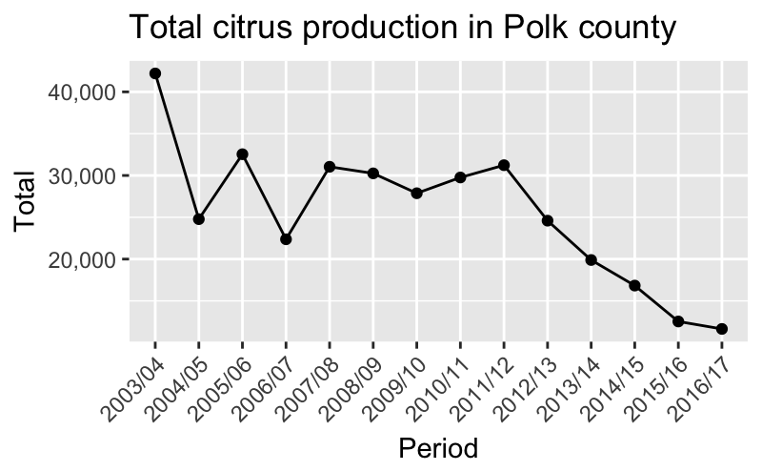**Figure 1** Total citrus production in boxes in Polk county from 2003/04 to 2016/17.

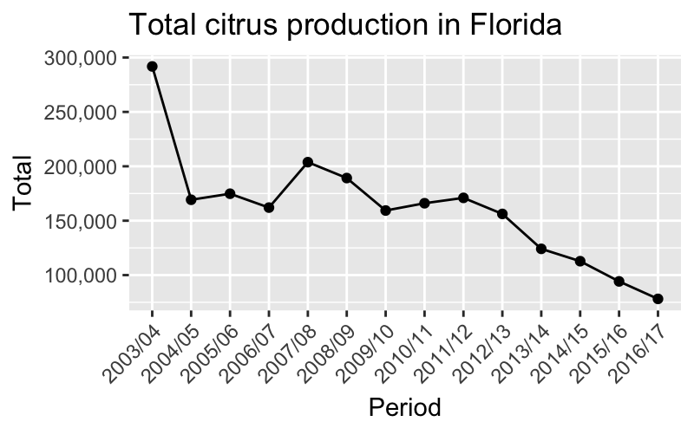

**Figure 2** Total citrus production in boxes in Florida from 2003/04 to 2016/17.

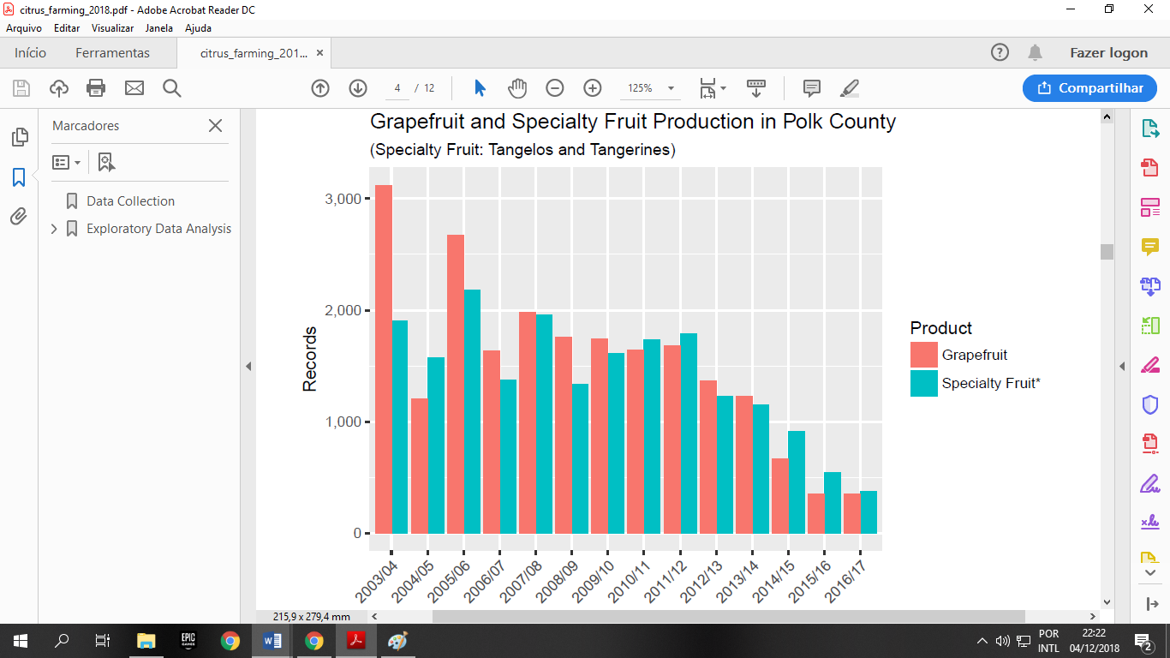

**Figure 3**. Grape and specialty fruit production in boxes in Polk county from 2003/04 to 2016/17.

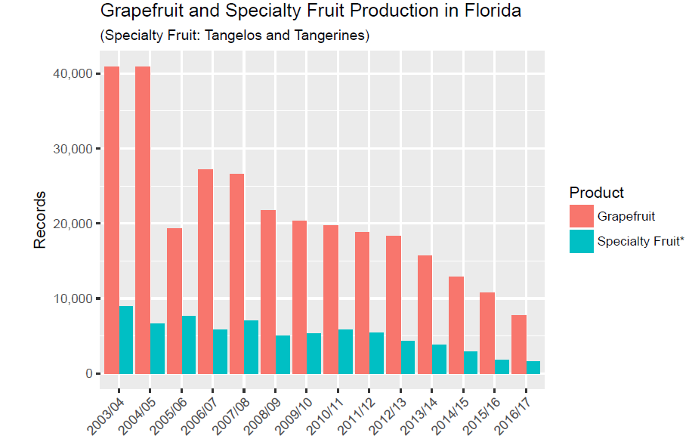

**Figure 4**. Grape and specialty fruit production in boxes in Florida from 2003/04 to 2016/17.

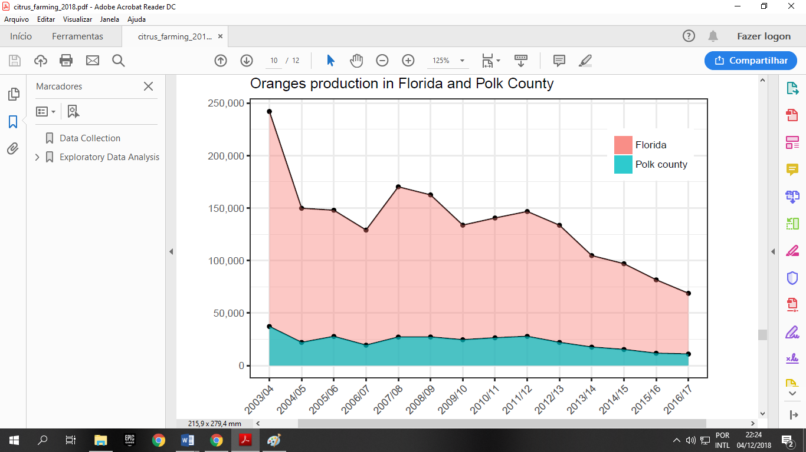

**Figure 5**. Orange production in boxes in Florida and Polk County from 2003/04 to 2016/17.

**BUDGETARY REQUIREMENTS**

During the research process, the main research tool used was the internet. It was not necessary to make any requests involving monetary transition. The graphs were generated using the R statistical programming language.

**DISCUSSION**

Data on the “greening” problem in Polk County are scarce, making the process of finding effective management measures challenging. Although the numbers of citrus production in the county have been steadily declining since 2005, with a sharp drop of 42% between the 2003/2004 and 2004/2005 crops, the disease was first identified in the county in 2007 (C. Oswalt, personal communication, November 15, 2018), evidencing the lack of monitoring at the time. Furthermore, there is no data on various information that are relevant to conduct scientific researches, such as the monitoring of physical-chemical properties of trees and soil, the percentages of the trees age, the relation between the differences in the infection between trees of different ages, and information on patterns of the disease spread.

One of the main elements that plays an essential role in the management of greening disease is the operation of various agencies and institutions which carry out assistance programs to the citrus industry. Table 1, Table 2 and Table 3 identify organizations at the local, state, and national levels respectively and the roles they play in dealing with the HLB problem.

The University of Florida is an institution that has several research and extension centers that operate on the HLB issue. These important academic centers, such as the Citrus Research and Education Center (CREC), the Citrus Research and Development Foundation (CRDF) and the Horticultural Science Department, play an essential role in helping the Florida citrus industry by exploring different areas of knowledge in different aspects of the greening problem. Citrus Health Management Areas (CHMA) is an extension project that has the ultimate goal of reducing the spread of citrus greening by encouraging the local farmers and stakeholders to work together to coordinate the psyllid control efforts. The extension agent in the Polk County is Chris Oswalt.

At the state level, the Florida Department of Agriculture and Consumer Services (FDACS) and the Florida Department of Citrus (FDOC) are institutions that promote the citrus industry by assisting growers and stimulating scientific research. On the other hand, at the national level, the United States Department of Agriculture (USDA) is the agricultural development center of the country and it is branched out into several agencies with different purposes. The USDA’s National Agricultural Statistics Service (NASS) procedure plays a key role in the overall analysis of problems in the agricultural sector as they conduct hundreds of accurate surveys covering all aspects of national agriculture. Thus, the NASS is the official agricultural database of the nation that allows the interpretation of the patterns presented by official articles published over the years.

In addition to government and university institutions involved in the process of developing more effective approaches to the topic of greening, private organizations within the citrus industry also have a relevant duty. Local farmer partnerships provided by grower’s associations, as shown in Table 4, ensure practical communication for joint decision-making. These organizations serve as a tool for aligning interventions measures based on scientific knowledge.

Nevertheless, even with the complex dynamics of the citrus industry and the numerous active farmers associations and research centers aiming to alleviate the current situation, the analysis of NASS data still emphasizes the ineffectiveness of current management measures concerning the greening problem. It is estimated that 95% of commercial groves are affected by the endemic bacterium (NIFA, 2017). Given the emphatic tendency of the disease spread intensification, it is necessary to do an evaluation of the control interventions of the HLB-pathosystem. Currently, the most appropriate approaches for short-term solutions are the prevention of disease spread by eradicating affected trees and vector control. Unfortunately, both pronged approaches are quite limited by the lack of scientific knowledge, increasing the complexity and magnitude of the problem.

The eradication of the trees affected by the bacteria is a valid strategy to prevent the spread of the disease to other trees and plantations. All trees that show the disease's symptoms and are less than 4 years old, are not bearing fruit or are infected up to 50-70% must be eradicated and replaced. Infected older trees must be intensively pruned (Batool, et al, 2007). However, this method aims to eradicate only organisms that are already expressing symptoms and does not consider organisms in the period prior the symptoms expression, the cryptic period. Little is known about this latent period, which can last several months depending on the age of the tree (Gottwald and McCollum, 2017). During this period, conventional detection methods do not work, making the spread of disease between organisms and farms uncontrollable (Gottwald and McCollum, 2017).

Vector control is also a management mechanism that in theory would have a tremendous impact in combating greening disease. However, once again the lack of scientific knowledge interferes with the effectiveness of the management measure. By means of chemical or biological measures, the absolute eradication of the prolific natural vector *Diaphorina Citri* is probably impossible (Gottwald and McCollum, 2017). The biological control of the agent of the disease of the greening through predators and parasites does not have sufficiently impacting potential (Haelbert and Manjunath, 2018). On the other hand, the synchronized chemical applications between the neighboring farms reveled to be more effective in controlling the *D. citri* population. Although timing of pesticides is critical, there is not enough research with “soft” (environmentally friendly) pesticides (Haelbert and Manjunath, 2018). Also, as the psyllid develops resistance to the pesticides, the growers are finding the sprays less and less effective (Buck, 2018).

Long-term measures are related to scientific research. Even with a variety of research centers associated with the USDA and the University of Florida, the technologies available to help the existing problem are still restricted. Although there has been a wide variety of researches aiming to explore many areas of this topic during 13 years of research in the United States, there are significant barriers to finding a solution to this puzzle. Technological tools such as RNAi, CRISPR technology and biotechnology are essential elements in conducting these investigations. Possible discoveries in the transgenic research field could help to find a future large-scale strategy for the citrus greening disease control. The main goal is to create genetically modified citrus with multigenic resistant to the bacteria (Gottwald and McCollum, 2017). However, it is important to consider the complications of a new generation of bacteria-resistant trees. The process of gene manipulation, field testing to confirm tree resistance, and government required testing for federal approval for commercial use would likely take decades.

After understanding the complications and complexities of the nature of the greening disease, the business analysis discussed should be synthetized in a conceptual framework of action. The action plan proposed in this article aims to achieve two essential goals: the control of the disease spread through the intensification and rearrangement of current control methods and the development of genetic modified trees resistant to HLB and to its possible future mutations through scientific research incentive.

The first stage in controlling the spread of the disease is to make the eradication of affected trees more stringent. A semiannual monitoring should be undertaken by the CHRP (Citrus Health Response Program) pest eradication and control team of each county. The eradication and pruning parameters continue the same as mentioned above. Even though there is a considerable portion of infected trees that are not detected because they are in the cryptic period and keep spreading the disease, the maximum control of the trees that can be detected by the frequent scouting would already cause a decrease in the propagation.

The second stage emphasizes the importance of the synchronization of pesticide applications in crops. The role of the CHMA (Citrus Health Management Areas) is fundamental in this aspect by being the mediators in the regional meetings of neighboring farms. The applications of chemicals by the farmers must be monitored and demanded by the region's citrus planter community in local grower associations meetings. FDACS should continue routine psyllid scouting and map the presence of the vector. It is tremendously important to carry out semiannual analysis of *D. citri* concentration change patterns to identify the effectiveness of pesticides.

Both control measures mentioned above are important short-term measures to contain as much as possible the HLB spread. However, the measure that can save the future of the citrus industry in Polk County and Florida is related to the increase and standardization of scientific research. As Table 1, Table 2 and Table 3 show, there are several research laboratories that are involved in the cause. Research in the areas related to the genetic engineering of trees to create resistant trees, the development of effective vector control measures and the broadening of the understanding about cryptic period for early disease detection should be strongly encouraged to create more affirmative strategies

**LITERATURE CITED**

Bové, J. (2006). Huanglonbing: a destructive, newsly-emerging, century-old disease of ci-

trus. *Journal of Plant Pathology, 88(1), 7-37.*

Batool, A., Iftikhar, Y., Mughal, S., Khan, M., Jaskani, M., Abbas M. and Khan, A. (2007).

Citrus greening disease – a major cause of citrus decline in the world – a review. *Hort.Sci.(Prague), 34,* 159-166.

Bronson, C. (2005). *Citrus Summary 2003-04.* Retrieved from: <https://www.nass.usda.gov/>

Statistics_by_State/Florida/Publications/Citrus/Citrus_Summary/200304/cs0304all.pdf

Buck, B. (2018, October 16). *New UF/IFAS entomologist: from a kid’s ‘lab’ to helping citrus*

*Growers.* [Web log post] Retrieved from [http://blogs.ifas.ufl.edu/news/2018/10/16/n ew-uf-ifas-entomologist-from-a-kids-lab-to-helping-citrus-growers/](http://blogs.ifas.ufl.edu/news/2018/10/16/n%20ew-uf-ifas-entomologist-from-a-kids-lab-to-helping-citrus-growers/)

Court, C., Hodges, A., Rahmani, M. and Spreen, T. (2017). Economic contributions of the

Florida citrus industry in 2015-16. *Gainesville, FL.* *Food and Resource Economics Department.*

Florida Department of Agriculture and Consumer Service (FDACS). (2015). *Florida agricul-*

*ture overview and statistics.* Retrieved from: [https://www.freshfromflorida.com/ Agriculture-Industry/Florida-Agriculture-Overview-and-Statistics](https://www.freshfromflorida.com/%20Agriculture-Industry/Florida-Agriculture-Overview-and-Statistics)

Florida Department of Citrus (FDOC). (n.da). *Huanglongbing (HLB)/citrus greening disease*

*information.* Retrieved from https://www.freshfromflorida.com /Divisions-Offices/Plant-Industry/Agriculture-Industry/Citrus-Health-ResponseProgram/Citrus -Diseases/HLB-Citrus-Greening

Gottwald, T. and McCollum, T. (2017). Huanglongbing solutions and the need for anti-con-

ventional thought. *Journal of Citrus Pathology, 4(1).*

##### Haelbert, S. and Manjunath, K. (2018). Asian citrus psyllids (Sternorrhyncha: Psyllidae) and

greening disease of citrus: a literature review and assessment of risk in Florida. *Florida Entomologist, v.101*(3), pp. 220-253.

Hickey, L. (2017, October 6). Citrus greening remains a problem in backyards citrus trees.

[Web log post]. Retrieved from [http://blogs.ifas.ufl.edu/manateeco/2017/10/06/citrus -](http://blogs.ifas.ufl.edu/manateeco/2017/10/06/citrus%20-)greening-remains-problem-backyard-citrus-trees/

Hodges, A. and Stevens, T. (2015) Economic contributions of agriculture, natural resources,

and related food industries in Polk county, Florida. *Gainesville, FL. University of Florida-IFAS, Food and Resource Economics Department*

Hodges, A., Rahmani, M. and Mulkey, D. (2006). Economic impacts of the Florida citrus

industry in 2003-2004*. Gainesville, FL. Food and Resource Economics Department.*

Mann, M., Fattah-Hosseini, S., Ammar, E. D., Stange, R., Warrick, E., Sturgeon, K., ... &

Heck, M. (2018). Diaphorina citri nymphs are resistant to morphological changes induced by “Candidatus Liberibacter asiaticus” in midgut epithelial cells. *Infection and immunity*, IAI-00889.

Martini, X., Rivera, M., Hoyte, A., Sétamou, M., & Stelinski, L. (2018). Effects of wind,

temperature, and barometric pressure on Asian citrus psyllid (Hemiptera: Liviidae) flight behavior. *Journal of economic entomology*.

National Institute of Food and Agriculture (NIFA). (2017). National institute of food and a-

griculture 2016 annual report. Retrieved from:[https://nifa.usda.gov/sites/default/files/ resource/NIFA-2016](https://nifa.usda.gov/sites/default/files/%20resource/NIFA-2016)-Annual-Report-Print-Version.pdf

Neate, R. (2016, Oct 16). *Feeling the squeeze: Florida faces worst orange harvest crisis in*

*a century*. The Guardian. Retrieved from: [https://www.theguardian.com/usnews/ 2016/oct/16/flor](https://www.theguardian.com/usnews/%202016/oct/16/flor)ida-oranges-juice-harvest-disease-hurricanes.

Neupane, D., Moss, C. and Bruggen, A. (2016). *Estimating citrus production loss due to*

*Huanglongbing in Florida.* University of Florida.

Putman, A. (2018, April 17). Florida citrus statistics 2016-2017. Retrieved from:

[https://ww](https://  www.nass.usda)

[w.nass.usda](https://  www.nass.usda).gov/Statistics_by_State/Florida/Publications/Citrus/Citrus_Statistics/201617/fcs1617.pdf

Putnam, A. (2017, March 29). *Florida Citrus Statistics 2015-2016.* Retrieved from:

[https://](https:// www)

[www](https:// www).nass.usda.gov/Statistics_by_State/Florida/Publications/Citrus/Citrus_Statistics/2015-16/fcs15 16.pdf

Spreen, T. and Zansler, M. (2015). Florida citrus production projection and consumption sce-

narios 2016-17 through 2015-16. Florida Citrus Commission: Florida Department of Citrus.